The site ReeledInfo’s intended purpose is to inform people who are interested in getting into fishing or already experienced looking for more info. The site is easy to navigate for people of all technological capabilities, and the font is easy to read.

<https://curranmark3.github.io/WebDesignProject/>

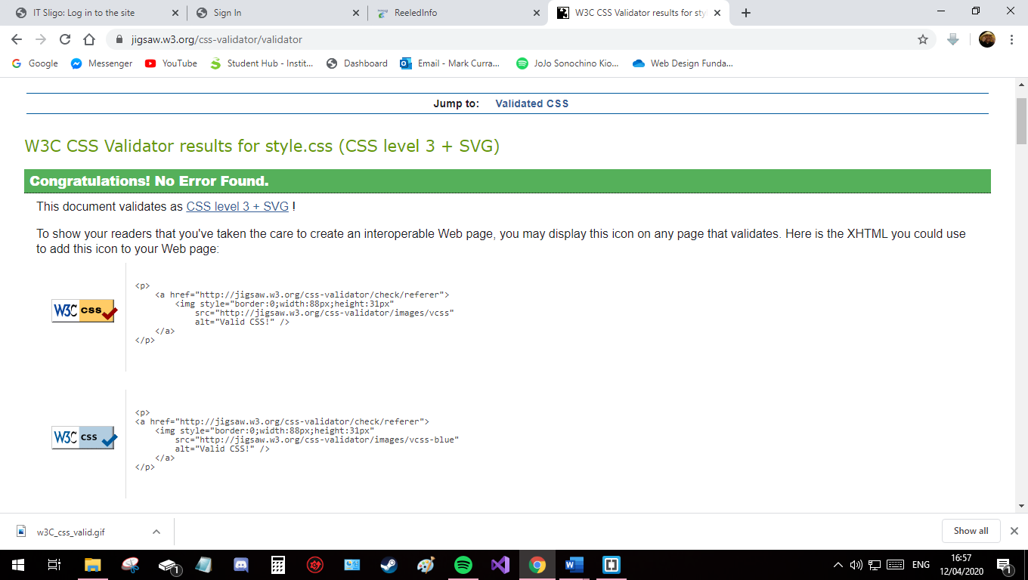

CSS fully valid for style.css

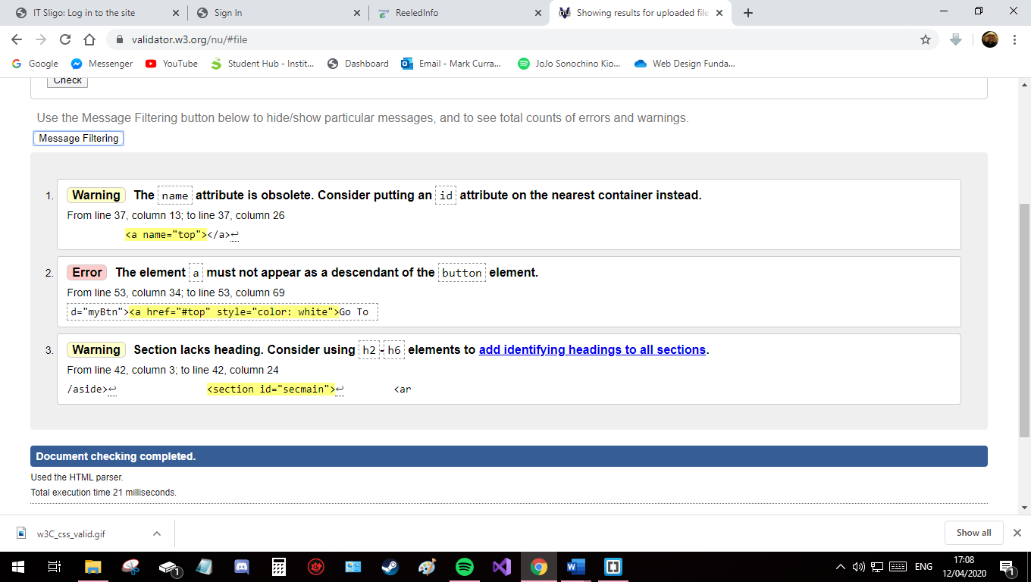

HTML for index.html validation (with majority of issues addressed)

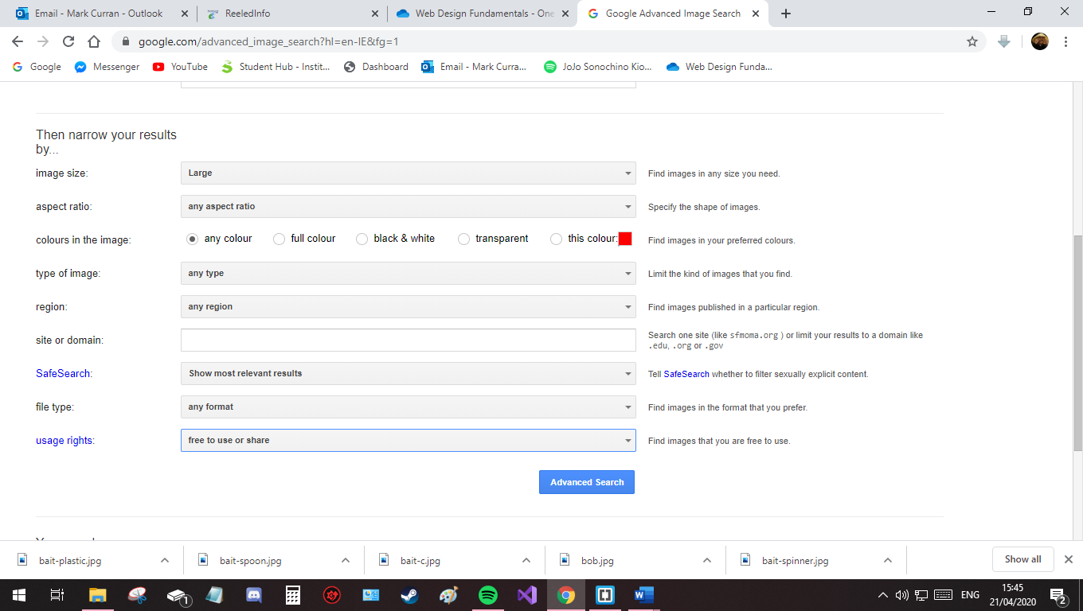

All images used in this site are either through the free to use or share setting in Google Images, or of my own photos.

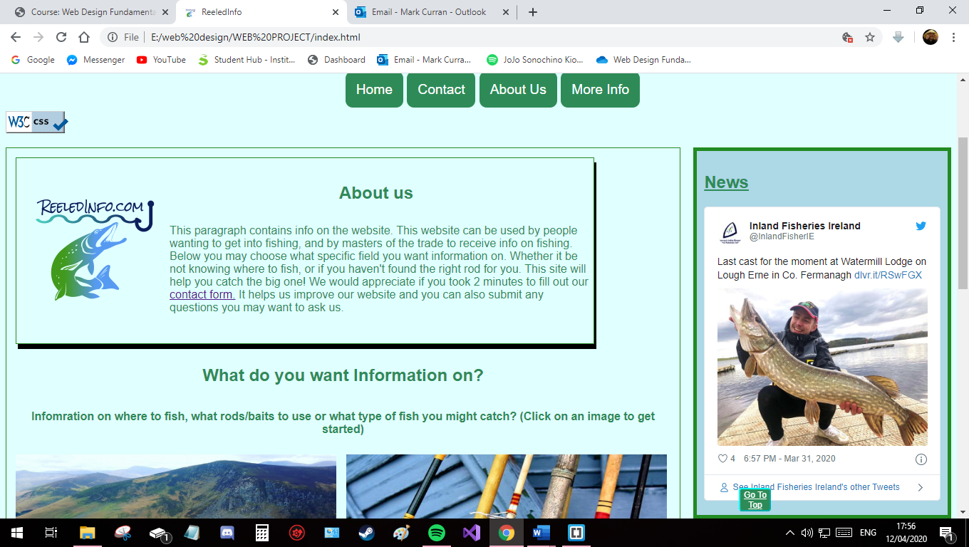

index.html is the homepage of my project. It allows the user to navigate to the three other main pages of the site (location, typesoffish, and rods), while also containing a twitter feed for Inland Fisheries Ireland and a reference to the contact form.

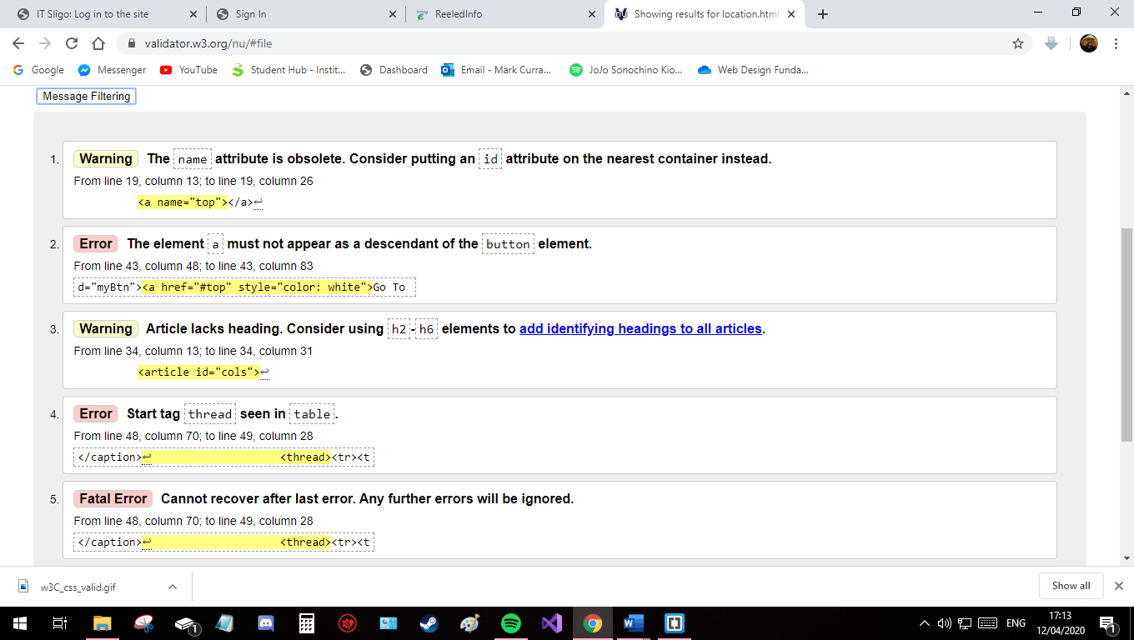

HTML for location.html validation (with majority of issues addressed).

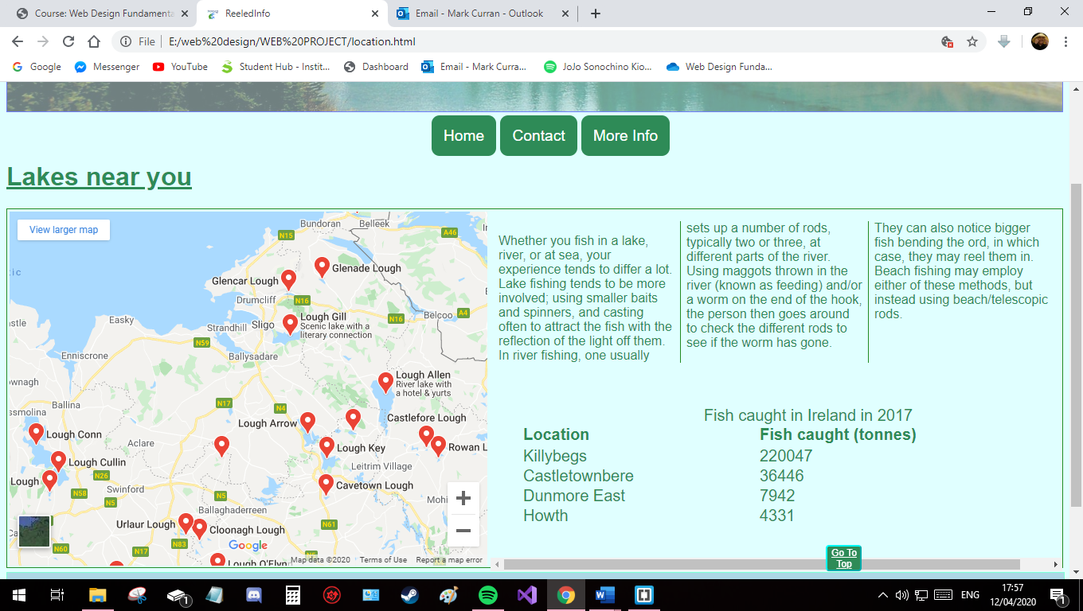This page’s main purpose is for the user to find places to fish near them using the embedded “lakes near me” google maps feature. They can also read up on the differences in fishing in different settings (lakes, beaches, rivers). This page contains a table on the tonnage of fish caught in Ireland in 2017.

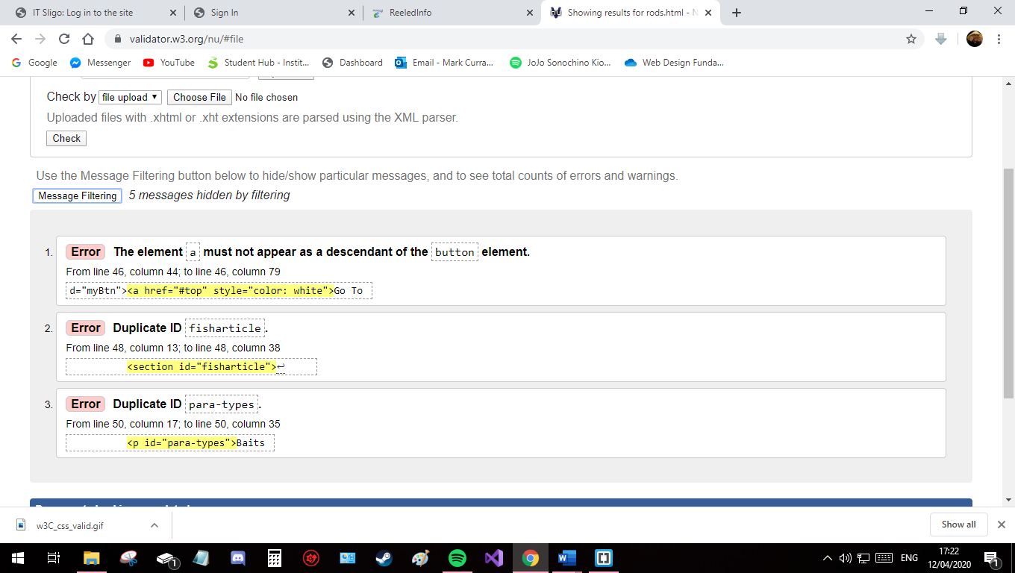

HTML for rods.html validation (with majority of issues addressed).

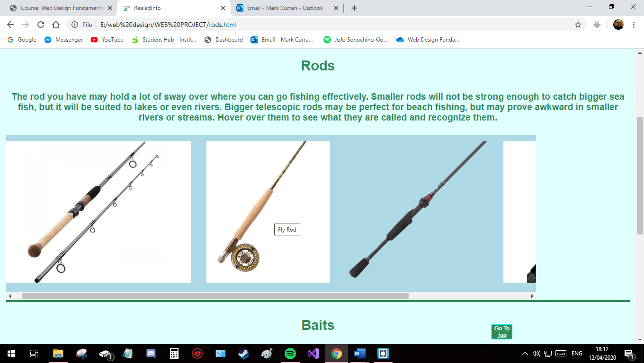This page contains two scroll menus containing images of different types of rods and baits respectively. It contains information on both; the images’ purpose is for the user to familiarise themselves with the different types, with the help of the image titles, and find out which ones they need according to their situation.

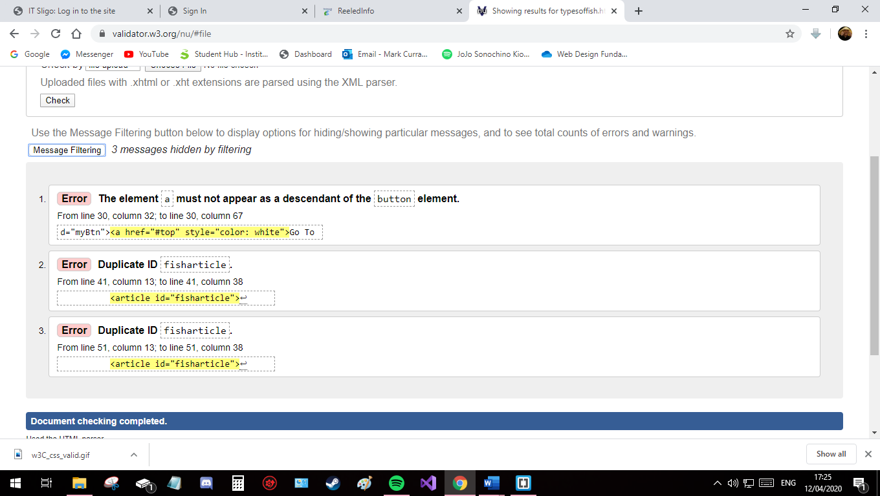 HTML for typesoffish.html validation (with majority of issues addressed).

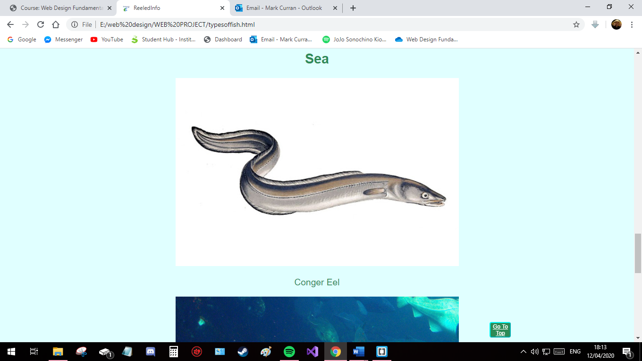 The page contains 3 articles on what types of fish the user may catch in rivers, lakes.

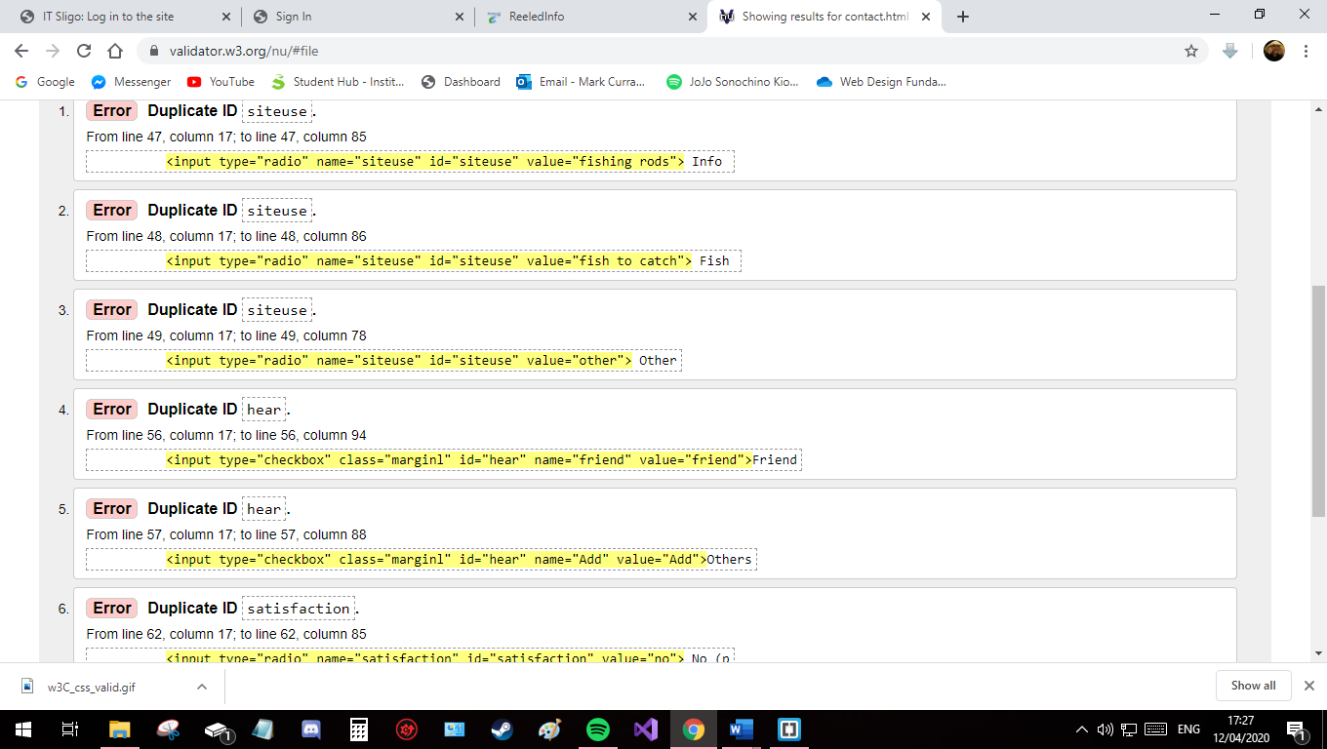HTML for contact.html validation (with majority of issues addressed).

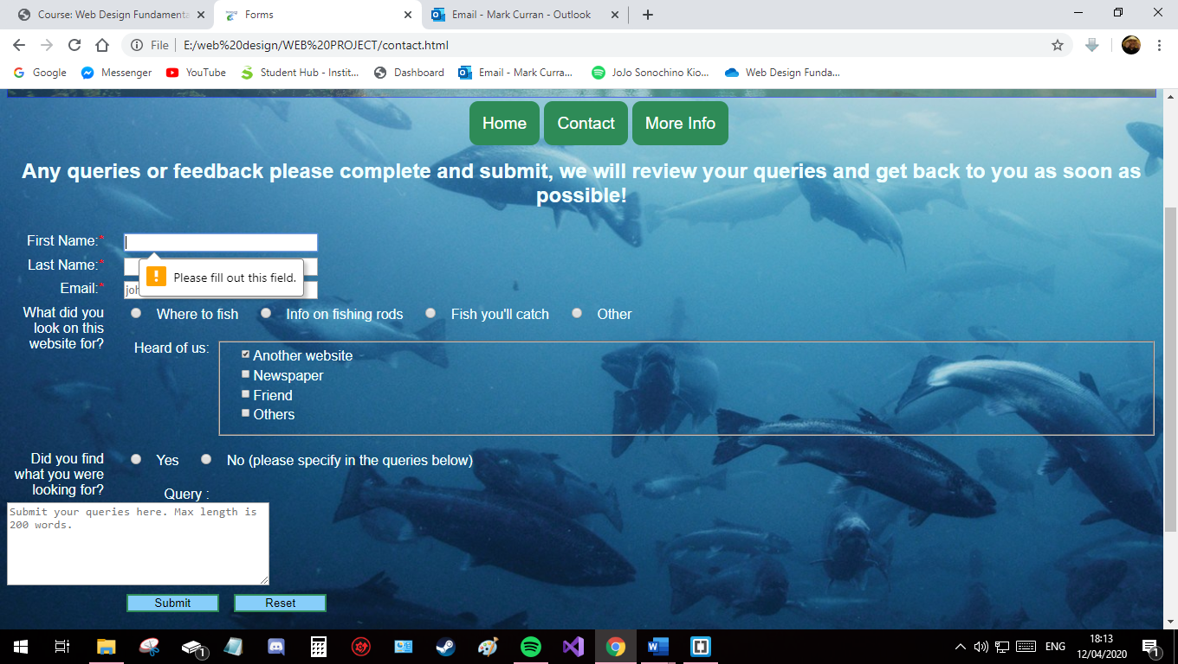The user is asked to complete this contact form on the homepage. This page is for feedback in general for the site, including those who have problems with the site. The information can be submitted, once the red asterisked mandatory fields are filled out, and validated on a server.